Miss Gilderoy, Mrs Young, Miss Rodham, Mrs Walton and Mrs Bourne would like to extend a warm welcome to Year 6.

Useful Information

PE Days

PE Days: Monday and Friday

All children will take part in PE twice a week so please make sure PE kits are worn to school on these days. As a reminder jewellery and earrings are not to be worn in these lessons and hair needs to be tied back. PE kits are black shorts and a plain white top. For outdoor PE in the colder months, we suggest the children wear jogging bottoms and their school jumper or hoody.
Please see Uniform Policy

Reading
Children must bring in their reading record each day and they will take an AR quiz after each book they finish reading. They will do this in class using the Accelerated Reader website.

We will assess the children regularly during the year to check their progress and to ensure they continue to read the right level text. We will feedback on your child’s progress during parent consultations.

Assessment

Ongoing teacher assessments will be carried out each term. Teachers will use termly age-appropriate tests and teacher judgement to assess each child. In year 6 we also have our statutory SATS tests in May, where the children complete maths, reading and SPAG assessment test papers.

Homework

Homework will be set each week by the class teachers. This will include their weekly spellings as well as either a grammar or maths activity based on their learning from that week. Spellings will be sent home on Friday and tested the following week on a Friday. These will be in paper form.

Children can also log in to Times Tables Rock Stars.

Items from home
Please bring in your book bag, a bottle of water and your lunch (unless you are having a school lunch). Please don't bring toys or other personal items.

Remember - if you have any questions, you can email us at school@wwlcp.school

Curriculum Overview

Please follow the link to view what we are learning each term

Curriculum

Recommended Reads
 | Class Novel | Age Appropriate Books
Year 6 | Explorer  Letters from the light house  A Christmas Carol by Tony Mitton  When the sky falls  holes | Skellig  The lost whale  Marcus Rashford you can do it  War horse  Skandar unicorn thief  Funky chickens (poetry)  Engineers making a difference  Murder most unladylike

Useful Websites
- Times Table Rock Stars
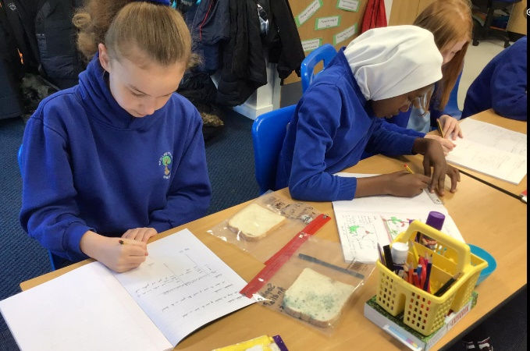
- Purple Mash



